Ideation Phase

Define the Problem Statements

|  |  |
| --- | --- |
| **Date** | 1st October 2022 |
| **Team ID** | PNT2022TMID54181 |
| **Project Name** | Project – WEB PHISHING DETECTION |
| **Maximum Marks** | 2 Marks |

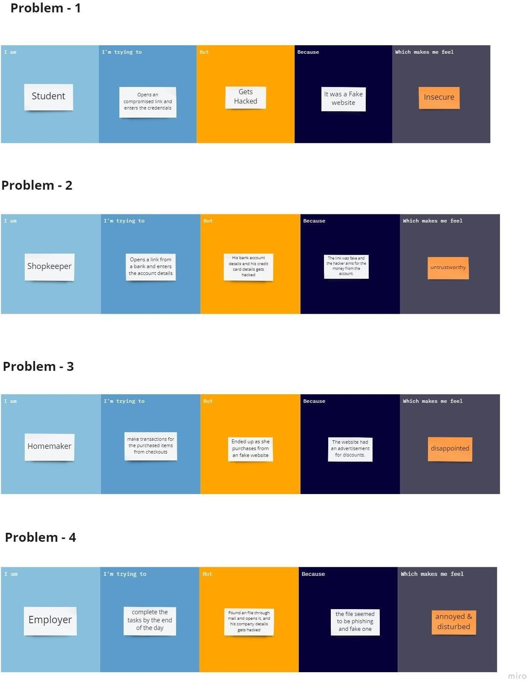

|  |  |  |  |  |  |
| --- | --- | --- | --- | --- | --- |
| **Problem Statement (PS)** | **I am (Customer)** | **I’m trying to** | **But** | **Because** | **Which makes me feel** |
| PS-1 | Student | Opens an compromised link and enters the credentials | Gets Hacked | It was a Fake website | Insecure |
| PS-2 | Shopkeeper | Opens a link from a bank and enters the account details | His bank account details and his credit card details gets  hacked | The link was fake and the hacker aims for the money from the account. | untrustworthy |
| PS-3 | Homemaker | make transactions for the purchased items from  checkouts | Ended up as she purchases from an fake website | The website had an advertisement for discounts. | disappointed |
| PS-4 | Employer | complete the tasks by the end of the day | Found an file through mail and opens it, and his company details gets  hacked | the file seemed to be phishing and fake one | annoyed & disturbed |